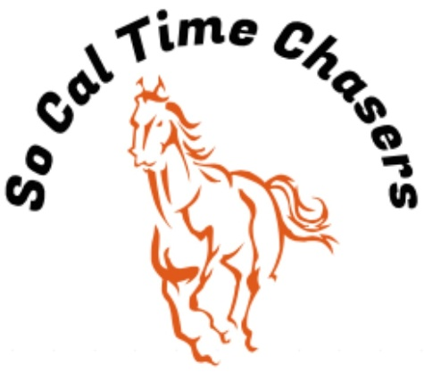
Board Meeting Minutes for
04/03/24

Location | In Person
Meeting called to order | 5:06 pm PST
Members in attendance
X | President: Bob Cranor
X | Vice President: Charla Cranor
X | Secretary: Shannon Cannon
X | Treasurer: Jessica Manning
 | Director at Large: Jennifer Scott
 | Director at Large: TBD
 | Volunteer Coordinator: TBD
 | Awards Coordinator: Kristen Renee

Agenda
Old business: None

Treasure Report:
Current Assets
Checking $2234.51
TOTAL ASSETS $2234.51

Show income $ 3043.00
Venmo $1884.00
Paypal $261.00
Show Deposit $ 898.00
Show Expenses $2533.00
Show Net $ 510.00

Club still owes Cranor Family $1000 for area fee they had to pay in advance for the Jan Show.

We continue to struggle with making any money to put towards the buckle series and day awards. We really need sponsors to help get this club up and running.

We overpaid $150 for the March show. That was due to the credit we got for Bob working the arena for open riding. Sara will credit that amount to us for the April show.

Shannon moved to approve the treasure report, Bob seconds it and all board approved.

- Recap Show: Feb 24 (41 riders)
- Issues at show – making sure everyone cleaned up before leaving. Sara complained about several areas.
- We had no time writing issues other than the time writers crossing out the leadliner names and adding the horse’s name. This needs to remain the leadliner name in the name of the horse per CGA state.
- The covered arena still could not be used due to not enough dirt. A lot of mention of frustration that we were not using the covered arena. Since Sara said she is putting the dirt back in and we will be able to use the covered arena in the April show.
- Any suggestions for people who cannot volunteer due to the arena being split? We will work with them to find spots to volunteer.
- Do we have a cut off for people having the ability to enter the buckle series? The cut off is now to be fair for the people who are seeing their standings.

- Here are the possible dates for next year. Sara will not hold them until we give her a $250 deposit per date for a total of $2250 for next year’s season.
- Sept 21
- Oct 19
- Nov 2nd or 9th
- Jan 18
- Feb 22
- March 15
- April 5
- May 3rd or 10th
- June 7

- CGA State Business:
- State show registration opened online Monday 1 April.

- New Business:
- We need to order the buckles for Molly’s within the next week in order to get the buckles in time. So far, we have a credit for 3 buckles (2 credit for Molly’s for adding their link to the website and $100 donated)
- 2 girls are going to go to Kiwanis to ask for help to get money to secure the deposit for the dates above.

Charla moves to adjourn. Bob seconds. Meeting ended at 5:30 pm

