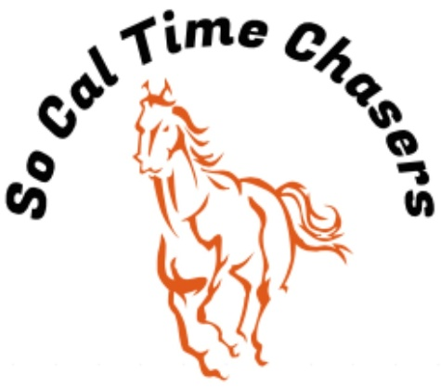
Board Meeting Minutes for
05/14/24

Location | In Person
Meeting called to order | 5:24 pm PST
Members in attendance
X | President: Bob Cranor
X | Vice President: Charla Cranor
X | Secretary: Shannon Cannon
X | Treasurer: Jessica Manning
 | Director at Large: Jennifer Scott
X | Director at Large: Colby Manning
 | Volunteer Coordinator: TBD
 | Awards Coordinator: Kristen Renee

Agenda
Old business: None

Treasure Report:
Current Assets
Checking $3013.33
Reserved from Buckle donations $600.00
TOTAL ASSETS $2413.33

Show income $2190.00
Venmo $1148.0
Paypal $258.00
Show Deposit $690.00
Raffle $94
Show Expenses $2209.86
Show Net -$19.86

Club still owes Cranor Family $1000 for area fee they had to pay in advance for the Jan Show.
Club wrote a check to Shannon for the full $807.37 owed for the buckle order. This now has been paid in full.

Shannon moved to approve the treasure report, Charla seconds it and all board approved.

- Recap Show: May 11 (29 riders)
- Speakers still seemed to be an issue. It was loud over the stands but could not hear outside the arena.
- We had no time writing issues at this show.
- Big thank you to the Boeh Family for Sponsoring 4 buckles and Lauren Veta for sponsoring 1 buckle. Just need 3 more buckle sponsors and they all will be paid for. Shannon is going to do a PowerPoint slide thanking the Buckle sponsors for the next show.
- We did ask riders to tag So Cal Time Chasers FB page when they post. So far none have.

- Here are the possible dates for next year. Sara will not hold them until we give her a deposit per date for next year’s season.
- Sept 21
- Oct 19
- Nov 2nd (Possible Christmas Tree Barrel Fun Event)
- Jan 18
- Feb 22
- March 15
- April 5
- May 10th
- June 7

- CGA State Business:
- State show registration opened online Monday 1 April.
- Jessica sent a check to CGA state for the $100 we owed for the state show.
- Bob is going to clarify with Marnie what State event District 5 signed up for. He is pretty sure it was Poles1.

- New Business:
- Shannon proposed a fun event for the Nov show.
- Shannon made a motion for the by-laws to get modified for only req 3 events ran per show to count as a show due to families sharing horses. Charla Seconded the motion.
- We discussed next year’s Membership prices, and all board members agree to $25 for Jr rider, $30 for Sr. riders and $40 for family memberships for the 2024/25 season.
- Nominations are needed for the following board positions:
  - Volunteer Coordinator
  - Award Coordinator
  - Youth Coordinator
  - Social Media Content Manager
  - Director at Large
- Bob moved to have Colby replace Jenifer Scott on the board as Director at Large since she has been unable to make the last few shows and meetings, Charla seconded it.
- How do we get more riders?
  - Get out next years flyers to horse areas and feed stores.
  - Offer a free Oct show - 1 raffle ticket will be given to current member per new rider brought to Sept show.
  - June Show give the donated Gel Pads for 1st place day prize.
  - Look into buying ribbons and or buttons in addition to day prizes next year.

Charla moves to adjourn. Bob seconds. Meeting ended at 6:02 pm

