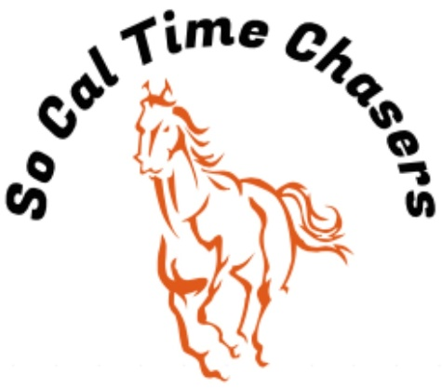
Board Meeting Minutes for
06/5/24

Location | In Person
Meeting called to order | 5:07 pm PST
Members in attendance
X | President: Bob Cranor
X | Vice President: Charla Cranor
X | Secretary: Shannon Cannon
X | Treasurer: Jessica Manning
X | Director at Large: Colby Manning
 | Director at Large:
 | Volunteer Coordinator: TBD
 | Awards Coordinator: Kristen Renee

Agenda
Old business: None

Treasure Report:
Current Assets
Checking $2761.50
TOTAL ASSETS $2308.30

Show income $3163.71
Venmo $1256
Paypal $528.71
Show Deposit $1290
Raffle $89
Show Expenses $2593.50
Show Net $570.21

Club still owes Cranor Family $1000 for area fee they had to pay in advance for the Jan Show.
$300 paid to equine services for the arena will be rolled over to the Sept show.

Charla moved to approve the treasure report, Bob seconds it and all board approved.

- Recap Show: June 1 (36 riders)
- Speakers still seemed to be an issue. It was loud over the stands but could not hear outside the arena.
- We had no time writing issues at this show.
- We did ask riders to tag So Cal Time Chasers FB page when they post. 2 tags
- Bob updated the Champions on the website

- CGA State Business:
- D5 has F8S Sunday

- New Business:
- 2 day show – 14 members said yes and 6 said no. Charla moved to change the Nov 2nd show from lakeside to KFR 2-3 November. We will do a costume contest and a Christmas tree Barrel Race $10 to run the $20 if they want the picture. $164 for Sat and Sun to include 4 jackpots.

- ESS Contract received – Some modifications to the contract need to be made on the below items
  - Price per arena
  - Her logo on our advertisements will not work
  - No food deliveries from outside vendors
  - Pictures of minors
- Propose to Sara Sept 7th for a Gymkhana clinic

Charla moves to adjourn. Bob seconds. Meeting ended at 5:55 pm

